**I. Export email data to .PST file in Outlook 2013, 2016, 2019**

1. In Outlook, click **File > Options**.

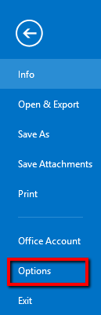

1. In the Outlook Options window, click **Advanced**.

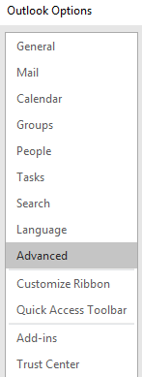

1. In the Export section, click **Export**.

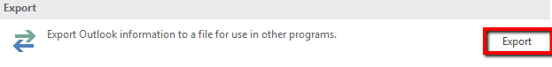

The Import and Export wizard launches.

1. In the Import and Export wizard, click **Export to a file**, and then click **Next**.

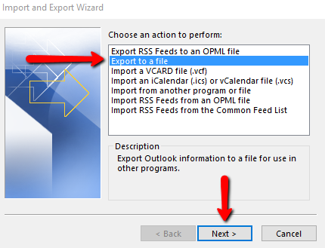

1. Click **Outlook Data File (.pst)**, and then click **Next**.

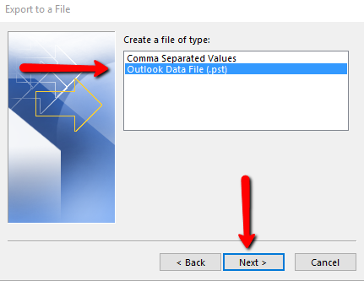

1. Select the folder that you want to export, and then click **Next**.

In this case, select the email address at the top of the folder list and select the checkbox for **Include subfolders** to export all data.

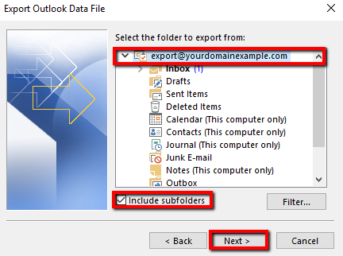

1. Click **Browse** and then select the location where you want to save the **.pst** file.
2. In the **File Name** box, type the name that you want to use for the new **.pst** file and click **OK**.

**Note:** You might be prompted to enter a password. This is optional and you can click **OK** to skip it.

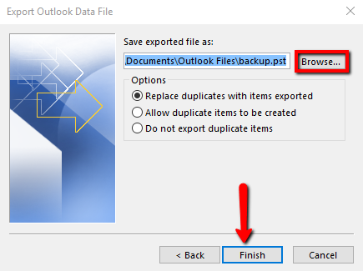

1. Click **Finish**.

**II. Import email data from .PST file in Outlook 2013, 2016, 2019**

1. In Outlook, click **File > Options** in the navigation bar.



1. In the **Outlook Options** window, click **Advanced**.



1. In the Export section, click **Export**.



The Import and Export Wizard launches.

1. In the Import and Export Wizard, click **Import from another program or file**, and then click **Next**.

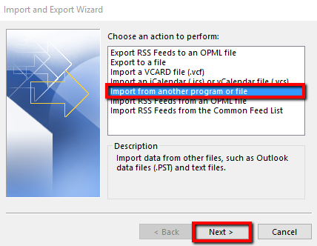

1. Click **Outlook Data File (.pst)**, and then click **Next**.



1. Click **Browse**, and then select the **Outlook Data File(.pst)** file that you want to import.

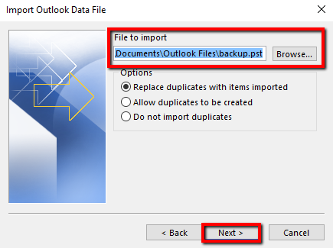

1. Select the folder from which to import. If you want to import all folders, select the Outlook Data File and the checkbox next to **Include subfolders**.

Select **Import items into the same folder in:** and select the email address you want the data imported into.

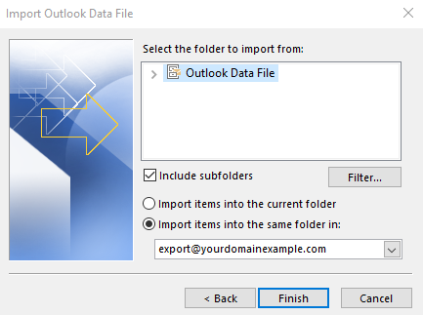

1. Click **Finish**. The Outlook Data File begins importing.

You have now successfully imported email data into Outlook.